D. Y. Patil College of College of Engineering and Technology, Kolhapur
Computer Science & Engineering

Subject – Advanced Programming Concepts
Assignment No. 13

Title of Mini-Project – Vehicle Rental Management System

Description –
The Vehicle Rental Management System is a web-based application developed to simplify the process of renting and managing vehicles. It provides a centralized platform for customers, administrators, and fleet managers. Customers can register, log in, browse available vehicles, view vehicle details, book vehicles for hourly or daily rental, apply discount coupons, and view their rental information. Administrators can manage vehicle records, pricing rules, coupons, and rental activities. Fleet managers can update vehicle availability, record maintenance details, and manage vehicle pickup and return operations.
The project is implemented using Python and the Flask web framework for backend processing, SQLite for database management, and HTML, CSS, Bootstrap, and JavaScript for the user interface. The database stores information related to users, vehicles, bookings, pricing rules, coupons, and maintenance records. The system calculates rental charges according to the selected rental duration and configured pricing rules. Payment functionality is simulated for demonstration purposes and does not process real transactions.
Objectives:
1. To provide an easy-to-use web interface for vehicle rental.
2. To maintain customer, vehicle, and booking records in a database.
3. To calculate rental charges based on hourly or daily rates.
4. To support vehicle availability, pickup, return, and maintenance management.
5. To reduce manual work and improve the organization of rental operations.
Software Requirements: Python, Flask, SQLite, HTML5, CSS3, Bootstrap, JavaScript, Visual Studio Code, and a modern web browser
Snapshots –

Figure 1: Home Page or Vehicle Listing Page

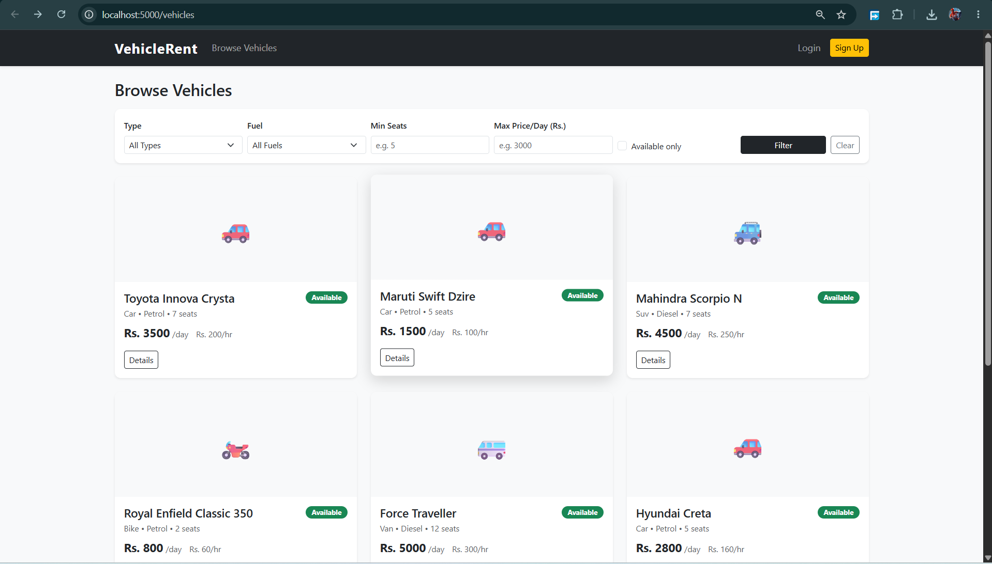

Figure 2: Customer Login Page

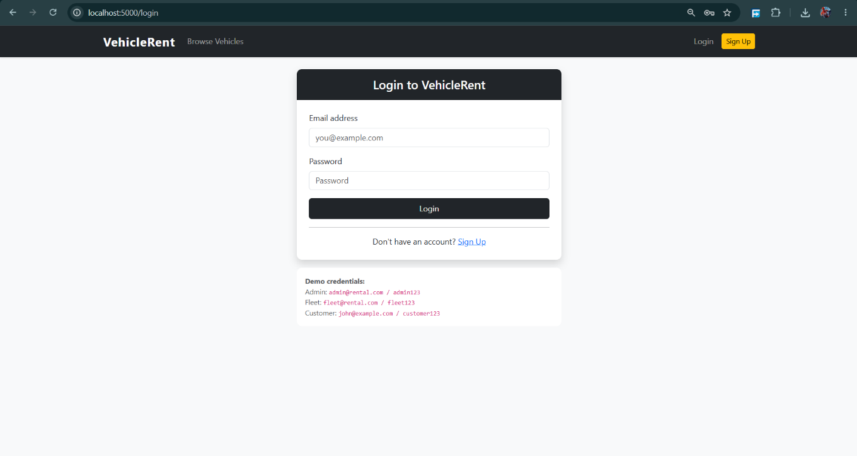

Figure 3: Vehicle Details and Booking Page

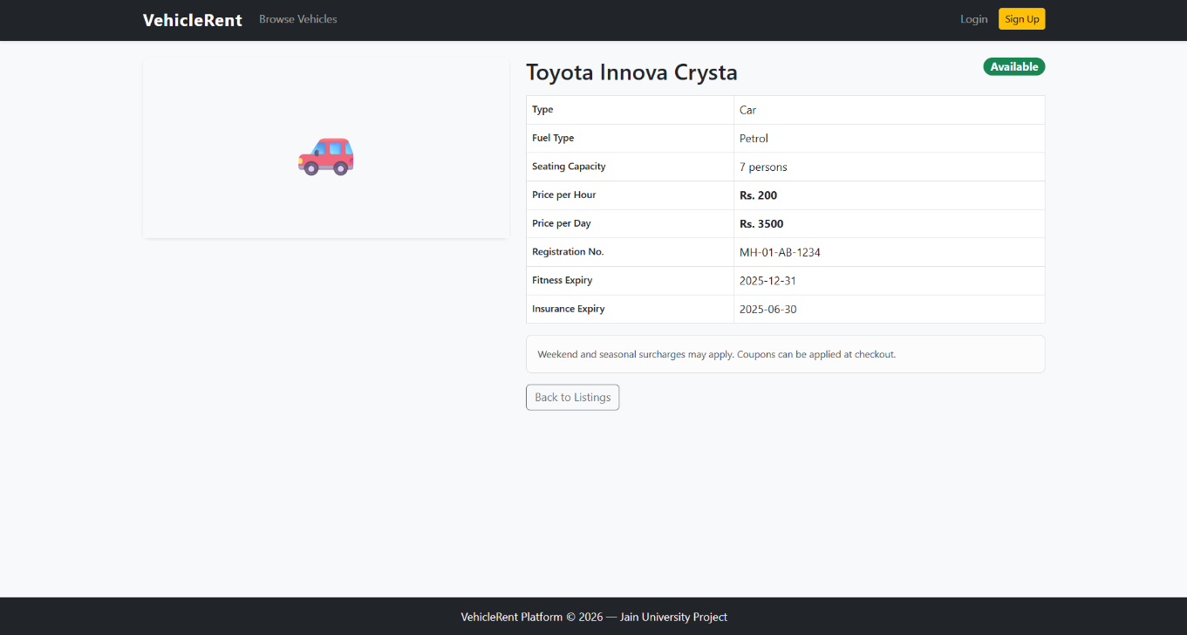

Figure 4: Rental Booking or Payment Page

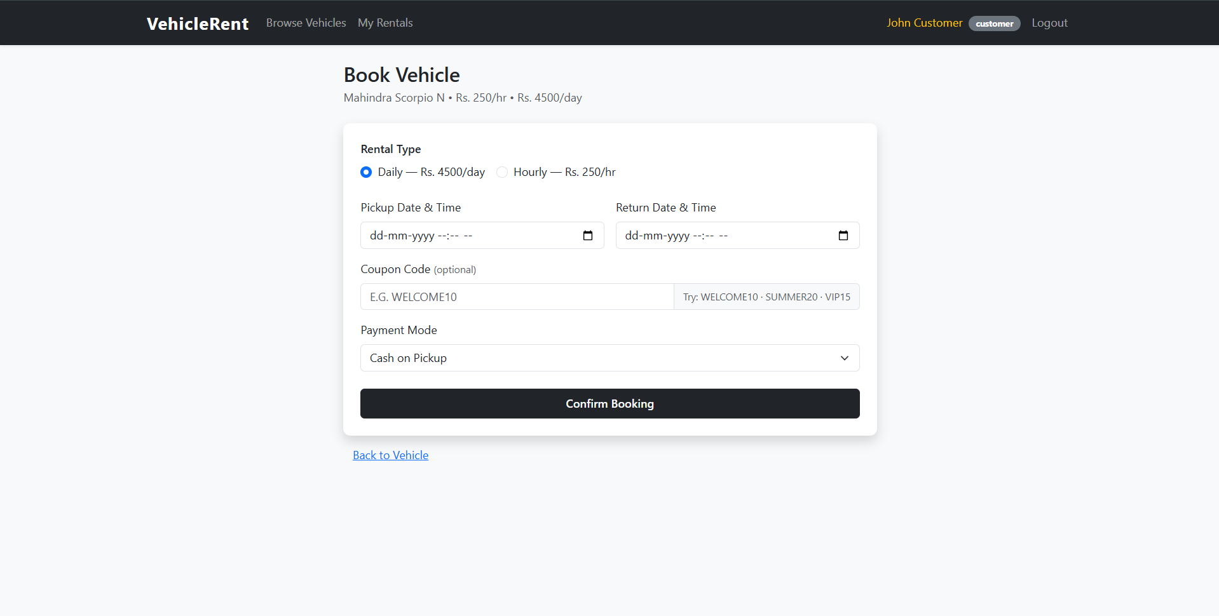

Figure 5: Customer Rental Dashboard

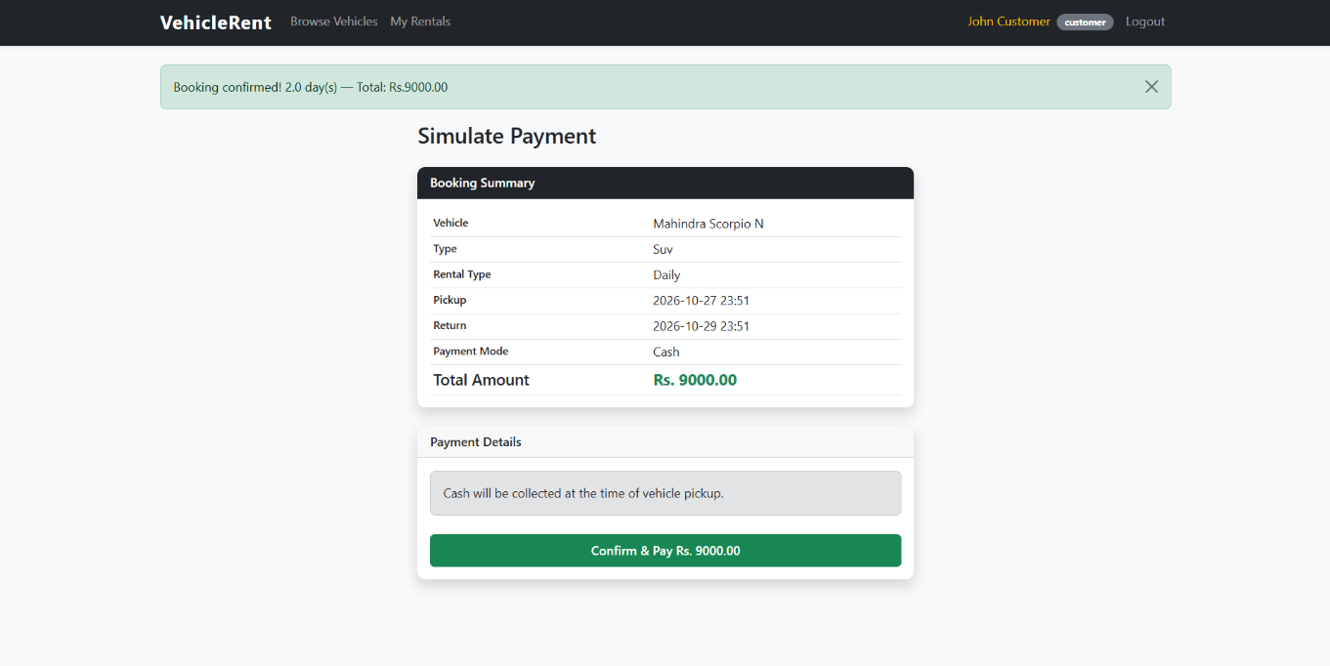

Figure 6: Administrator Dashboard
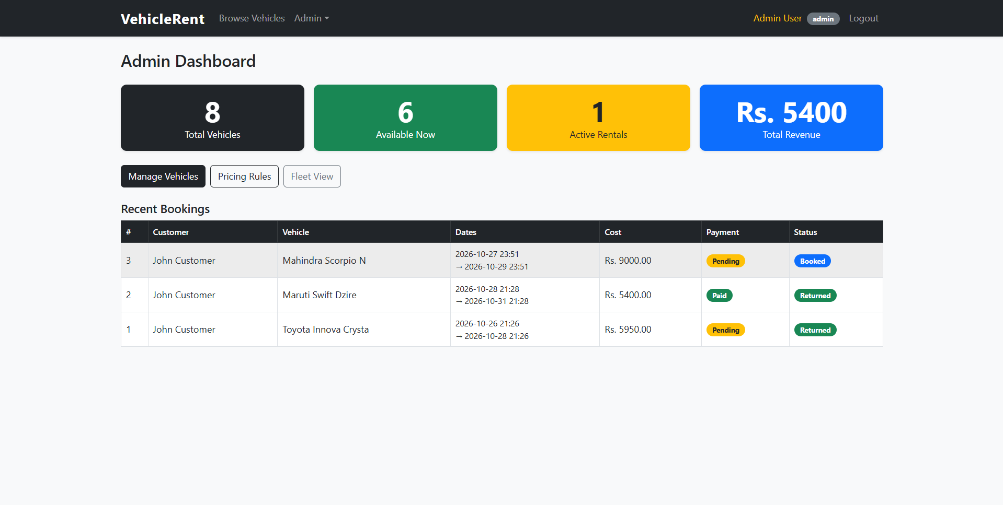

Figure 7: Fleet Manager Dashboard

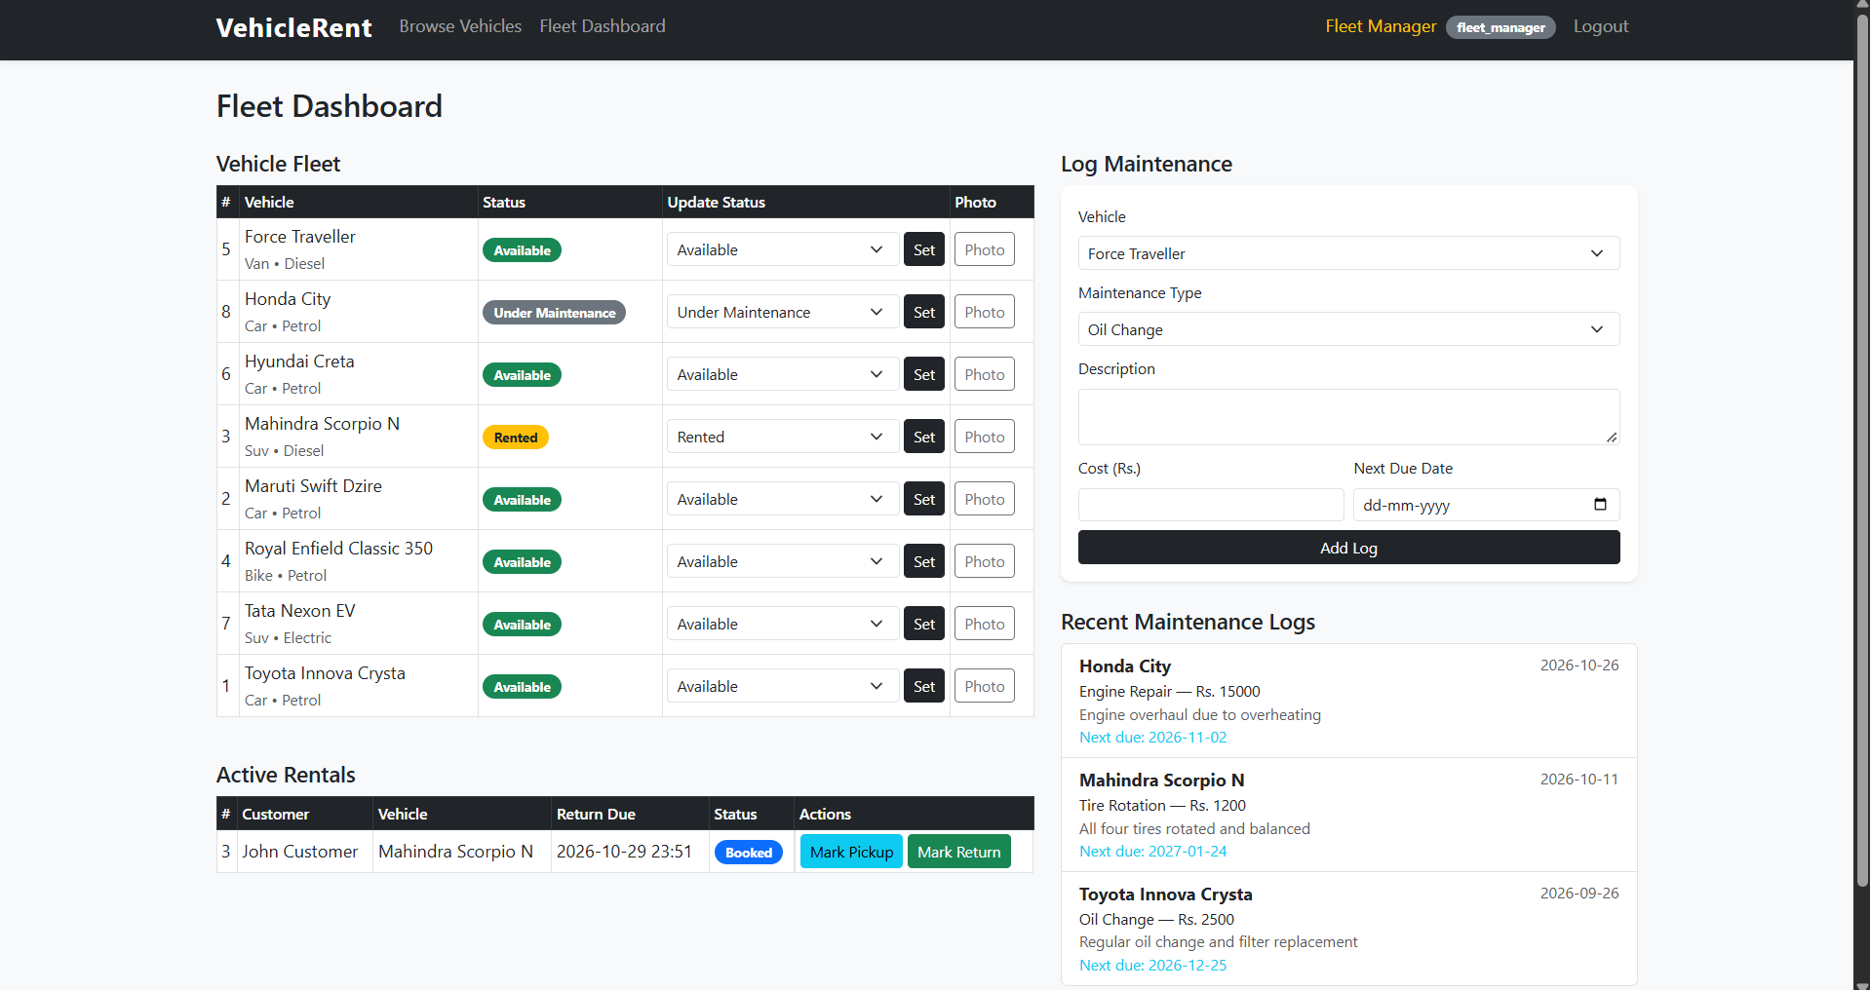

Date of Submission –

Juno Roll No | Name of Student | Sign
85 | Shreyash Sachin Kamble
76 | Urja Amit Gurav
81 | Prachi Gajanan Haval

